**Day-4**

**Scopes in javascript**:

A scope in JavaScript defines the accessibility or life or visibility of variables and functions. When you declare a variable or a function, its scope determines where it can be accessed from within your code.

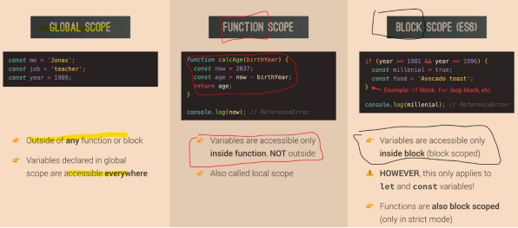

**Global Scope**:

Variables declared Globally (outside any function) have Global Scope. Global variables can be accessed from anywhere in a JavaScript program.

var a=10

{

var x = 2;

}

// x can be used here

**Block Scope**:

Variables declared within a block cannot be accessed from outside of the block.

{

let x = 2;

}

// x can NOT be used here

**Local Scope**:

Variables declared inside a function have local scope. They can only be accessed within that function. They cannot be accessed from the outside.

function myFunction() {

var a = "skills";

// code here CAN use a

}

// code here can NOT use a